The charts below give information on the location and types of dance classes young people in a town in Australia are currently attending.
Summarise the information by selecting and reporting the main features, and make comparisons where relevant.
Write at least 150 words.
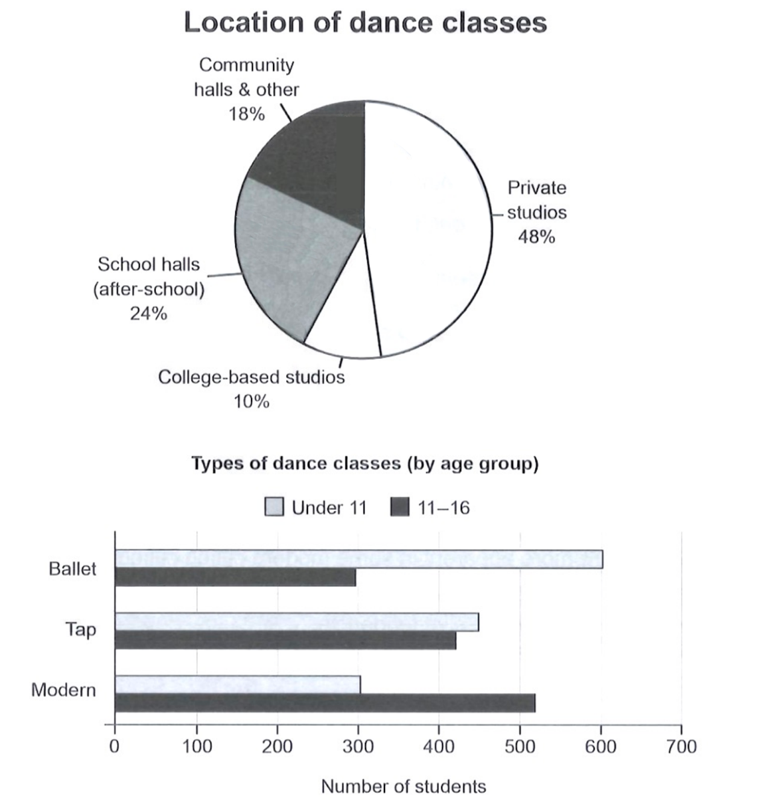
The pie chart illustrates the location of danced classes attending by young people in an Australian town and the bar chart shows the types of those classes.

Overall, almost half of the young people attend dance classes in private studios and college-based studios are the least popular selection. Ballet classes are most popular among children under 11 and the least among 11-16 students. Tap dance classes have roughly the same number of attendants of both ages and modern dance classes attract the most children between 11 and 16.

In terms of the location of dance classes, private studios are the most popular place, which have the proportion of 48%. College-based studios dance classes are the least popular among students, which are taken by only 10% of children. Dance classes in community halls and other places rank fourth among five locations, but still have the number of 18%, which it only a bit lower than the 24% of school halls (after-school).

When it comes to the types of dance classes, the number of attendants under 11 of ballet classes is the most among all other types and ages, at about 600. Ballet is also the least popular type of dance among students from 11-16, at the figure around 300, which is closed to the number of children who attend the modern dance classes. Modern dance is the most attractive type of dance for children from 11-16, which have more than 500 students.

